Ideation Phase

Define the Problem Statements

|  |  |
| --- | --- |
| Date | 13 October 2022 |
| Team ID | PNT2022TMID51106 |
| Project Name | Hazardous area monitoring for Industrial plant Powered by IoT |
| Maximum Marks | 2 Marks |

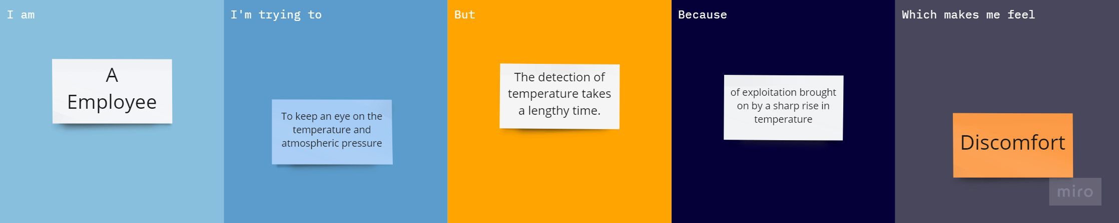

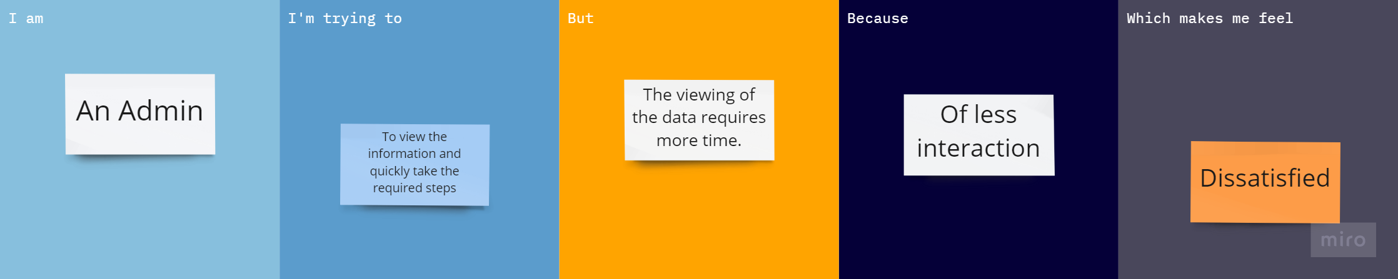

|  |  |  |  |  |  |
| --- | --- | --- | --- | --- | --- |
| **PROBLEM STATEMENT (PS)** | **I AM (CUSTOMER)** | **I AM TRYING TO** | **BUT** | **BECAUSE** | **WHICH MAKES ME FEEL** |
| PS-1 | A  Employee | To keep an eye on the temperature and atmospheric pressure | The detection of temperature takes a lengthy time. | Of exploitation brought on by a sharp rise in temperature | Discomfort |
| PS-2 | An Admin | To view the information and quickly take the required steps | The viewing of the data requires more time. | Of less interaction | Dissatisified |